[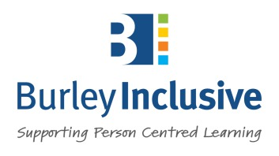](https://www.burleyinclusive.co.uk/)

Burley **Inclusive**

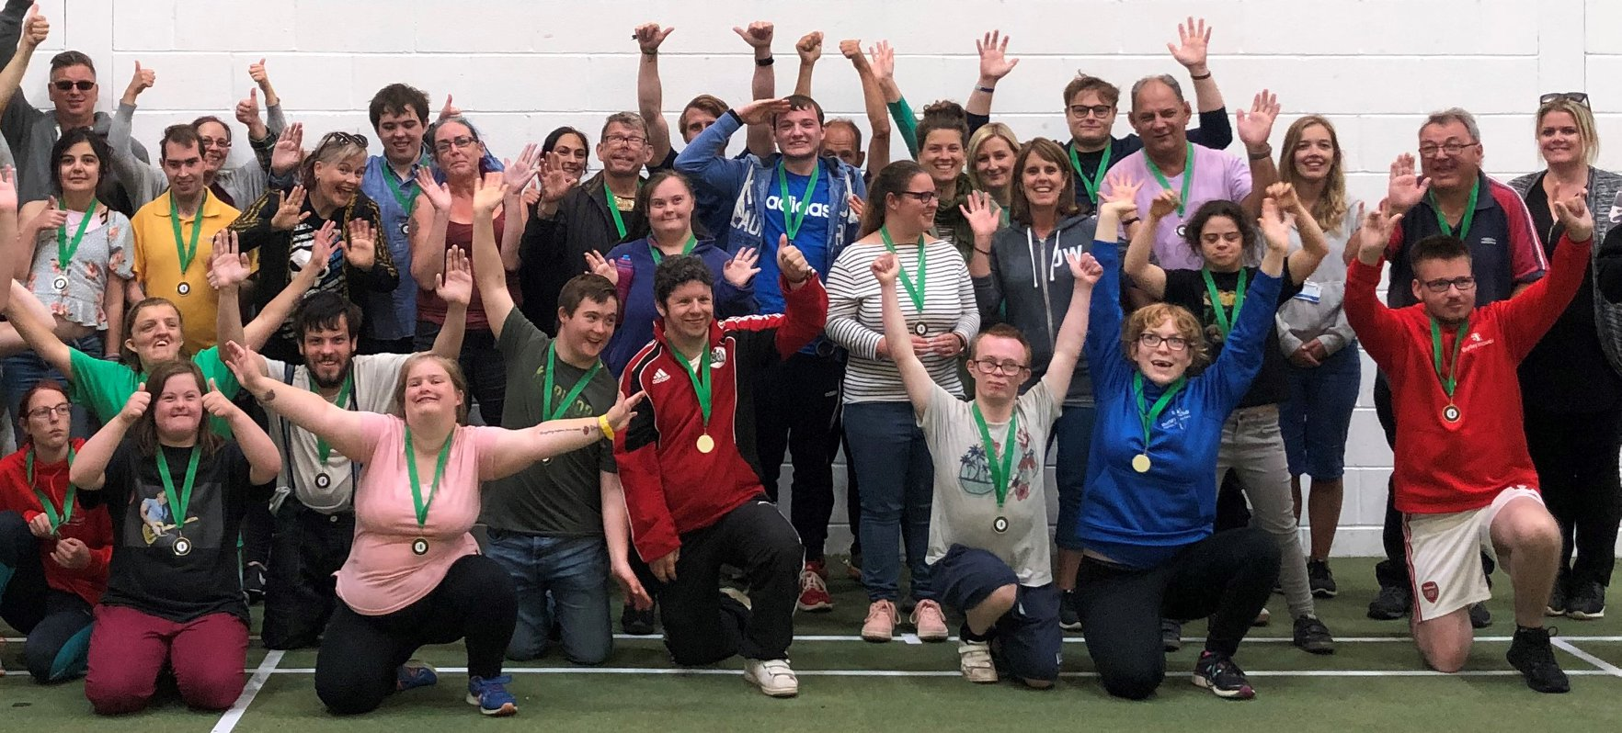

**Referral Form 2022**

**+++++++++++++++**

[](https://www.burleyinclusive.co.uk/s/cc_images/teaserbox_68483732.png?t=1521484555)

**Burley Inclusive Referral Form**

Before completing this form please make sure you have read our prospectus.

Our prospectus is available in **audio** and **video** at **www.burleyinclusive.co.uk**

**Learner Details**

|  |  |
| --- | --- |
| **Potential learners name:** |  |
| **Potential student’s date of birth:** |  |
| **Potential student’s home address:** |  |

**Education or Social Care Pathway**

Please mark below if you are making a referral for the Education and Social Care Pathway.

|  |  |  |
| --- | --- | --- |
| **Education Pathway** | **Social Care Pathway** | **Unsure** |
|  |  |  |

|  |  |
| --- | --- |
| **Current education provision:**  (Please include the date on which this provision will end) |  |
| **Does the student have an active Education, Health and Care Plan (EHCP) in place?** |  |
| **Are any existing outcomes still ongoing?** (Please refer to outcomes listed on the student’s EHCP or care plan that have not been met at this time) |  |
| **Name of North Somerset SEN officer** |  |
| **Next Annual Review Date** |  |

**Education Details**

**Social Worker Details**

|  |  |
| --- | --- |
| **Name of the student’s social worker:** |  |
| **Social worker’s email:** |  |
| **Social worker’s telephone:** |  |

**Parent / Carer Details**

|  |  |
| --- | --- |
| **Primary parent / carers name:** |  |
| **Email:** |  |
| **Telephone:** |  |
| **Address:** (Just put ‘same as student’ if the potential student lives at the same address) |  |

**Referrer Details**

|  |  |
| --- | --- |
| **Name of person making the referral:** |  |
| **Your organisation and job role:**  (If not covered above) |  |
| **Your email:** (If not covered above) |  |
| **Your telephone:** (If not covered above) |  |

**Terms of Service**

Burley Inclusive help every learner to achieve greater levels of independence and reduce their reliance on their support staff over time. All learners progress toward longer term outcomes, including crossing roads, using public transport, timekeeping and employment skills. Learners are expected to work toward these outcomes according to the direction of staff and with a level of independence demonstrated by their assessed ability, as stipulated in the Service Agreement.

Burley Inclusive are not registered with the Care Quality Commission and does not provide personal care, and its teaching takes place at instructional ranges determined by its staff, including distances where the learner may be out of sight of staff.

**Please email this completed form to:**

[transitions@burleyinclusive.co.uk](mailto:transitions@burleyinclusive.co.uk)

If you have any questions about this form, our transitions process, or our unique approach please call: **01934 808613**

**Alternatively post the form to:**

Burley Inclusive Ltd

36 Pure Offices, Pastures Ave, St Georges,

Weston-s-Mare, North Somerset, BS22 7SB